Software Design and Development

Fall 2013

System Design Document

By
Stephen Moore, Christopher Pagan, Keith Chang, Justin Tavares, Mariama Barr – Dallas, and Michael Tang

Writing Instructions

Do not have anything the Software Quality Assurance Organization could call a defect.

Be sure that your document is

- Complete - No information is missing
- Clear - Every sentence's meaning must be clear to all parties
- Consistent – The writing style and notation is consistent throughout the document and the document does not contradict itself

Remember that you are required to do a team review of this document.

When you think you are done with the SDD, ask yourself, "Could someone who was not part of the development of this SDD write the corresponding code?"

[Put Company name and Product name here]
System Design Document

Table of Contents

Page

1. Introduction

  - Purpose of This Document
  - References

- System Architecture

2.1 Architectural Design
2.2 Decomposition Description

3. Persistent Data Design

5.1 Database Descriptions
5.2 File Descriptions

- Requirements Matrix

Appendix A – Team percent contribution, Team sign-off, Customer acceptance

- Introduction

1.1 Purpose of This Document

State the purpose of the document and specify the intended readership. Briefly summarize the content. [One paragraph]

1.2 References

Provide a list of all applicable and referenced documents and other media. Minimally, a reference to your SRS document goes here. If you used any other documents or references to arrive at this design (e.g., the Somerville text, UML references, documents provided by the customer, web sites), list them here. See the Writing Resources on the CMSC 345 web site for the appropriate formats for references.

- System Architecture

2.1 Architectural Design

Draw a diagram that represents the logical software architecture of your system. Describe what you are trying to communicate to the reader with the diagram.
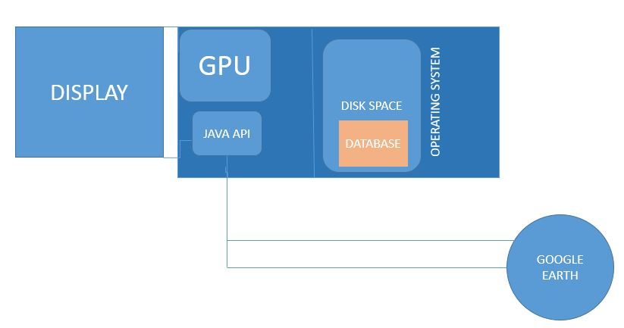

The purpose of this diagram is to show the inner-workings of the software in terms of the following: the storage system (database), the GUI, the Google Earth Java API. This diagram exhibits how each component is connected to create the user-interactive software.

Describe the technology (hardware and software) that your system will use. If your system is more than a desktop system (e.g., a client-server system), draw a corresponding technology architecture diagram.

Software will be compatible with the Windows OS. Software will use a GUI (Global User Interface) to graphically interact with the user. Software will use the host operating system’s GPU (Graphical Processing Unit) to run Java graphics processes. Software will use the host operating system’s CPU (Central Processing Unit) to run Java processes. Software will use webserver (port 80) to access Google Earth application. Software will use Google Earth Java API to access the following data: Places, distances, travel time (flight/driving at a specified number of miles per hour).

Illustrate and describe as much as you currently know about the system’s architecture. Use the architecture drawings in Mr. Roache’s Software Design: Requirements to Code lecture as a guide. You may also want to search the web for other examples.

[Two to three substantial paragraphs]

2.2 Decomposition Description

Illustrate and describe the decomposition into components of the system that you presented in Section 2.1 (e.g., functions, objects, scripts, files). This is the view of the system as you know it at this point in time. Provide diagrams as follows:

Functions – If your system is purely procedural, illustrate the interrelationships of its functions using a structural decomposition (hierarchy) diagram. Label the connections (interfaces) with general names (e.g., “student information”).

Object-oriented – If your system is object-oriented, use class diagrams to illustrate the implementation design of your system. Include any attributes and methods (public, private, and protected, constructors, accessors, and mutators) that are known as of this time. Use the UML class diagrams reference at the end of this document as a reference.

Hybrid – If your system contains both functions and classes, you need to include both a structural decomposition diagram and implementation class diagrams.

Other – If you are using PHP or another language that cannot be adequately described using a structural decomposition diagram and/or class diagrams, create custom illustrations. Show implementation components of the system (e.g., scripts, files) and their relationships.

Regardless of the type of diagram(s) that you use, refer the reader to the diagram(s) and describe what it is intended to communicate. Give a brief description of each of the components. If you are using a pre-defined pattern (e.g., Model-View-Controller), explain this to the reader. [Two to three substantial paragraphs]

Object-Oriented Design
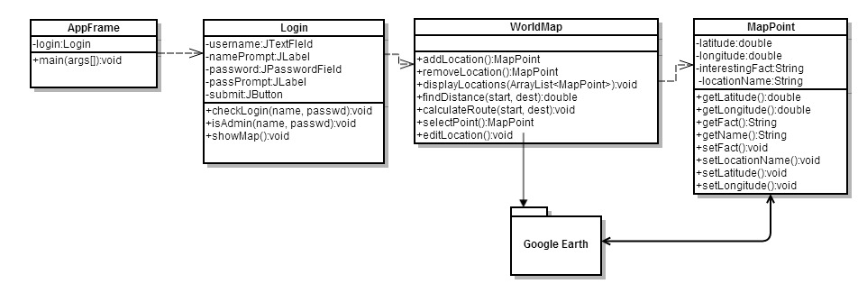
Figure 1: UML Diagram of Application

Figure 1 is the overall design of the software. The user is first greeted with the GUI prompting the user with the login details. After the user submits the details, their information is looked up in the database and verifies whether or not the user is authorized to use the application and whether or not the verified user has administrator privileges. The program then interfaces with Google Earth and shows the map containing all the locations that have been added. If the user is an administrator, he or she can add locations, remove locations, and edit location details. When a starting and ending points are selected, the user can determine the distance and route between the two points.

The software utilizes Google Earth to perform most of the processing. Google Earth is used to show the map to the end user and points are selected from that application. It is also used to calculate the route between any two locations because it already possesses the functionality to do so. Other backend processes are for adding, removing, editing map locations.

- Persistent Data Design

  - Database Descriptions

Describe the database(s) used by the system. Include a diagram of the schema. You may use an entity-relationship (ER) diagram, or you may create your own diagram type (e.g., a collection of tables). For each field in a database, give its name, data type (e.g., int, double), size (e.g., strings), and description of what it represents. Basically, give all of the information that a programmer must have to implement the database. If no databases are used, simply state so. [Length is whatever it takes]

  - File Descriptions

Describe the file(s) used by the system. Include a diagram of the file structure. For each field in a file, give its name, data type (e.g., int, double), size (e.g., strings), and description of what it represents. Basically, give all of the information that a programmer must have to implement the file. If no files are used, simply state so. Supplement your description with a sample file(s). [Length is whatever it takes]

No additional files are needed for the system.

- Requirements Matrix

Use a tabular format to show which system components (e.g., functions and/or methods) satisfy each of the functional requirements from the SRS. Refer to the functional requirements by use case number and name.

Appendix A – Team percent contribution, Team sign-off, Customer acceptance

Sign off Agreement Between Customer and Contractor

Describe what the customer and your team are agreeing to when all sign off on this document. [One paragraph] Include a statement that explains the procedure to be used in case there are future changes to the document. [One paragraph]

Team Review Sign-off

Provide a brief paragraph stating that all members of the team have reviewed the document and agree on its content and format. Provide lines for typed names, signatures, dates, and comments for each team member. The comment areas are to be used to state any minor points regarding the document that members may not agree with. Note that there cannot be any major points of contention.

Document Contributions

Remember that each team member must contribute to the writing (includes diagrams) for each document produced.

FYI Unified Modeling Language (UML)
Class Diagrams

Reference: UML Distilled, 2nd edition, Martin Fowler and Kendall Scott, 2000

Note: The information below has been modified slightly to meet the purposes of CMSC 345

Symbols:

Class – Represented by a box as follows:

Class Name
Attributes
Operations
Class Name

Navigability – Represented by a solid line with an arrowhead at one or both ends (unidirectional or bidirectional association, respectively). Indicates the direction(s) of an association between classes. (Below, A can navigate to B, but not the reverse.)

A
B

Generalization – Represented by a solid line with a hollow arrowhead at one end. Indicates that one class is a generalization of another. (Below, B is a generalization of A.)
A
B

Composition – Represented by a solid line with a solid diamond at one end. Indicates that an instance of one class is “owned” by a single instance of another. (Below, an instance of B is owned by a single instance of class A. Note: if an instance of A is deallocated, the associated instance(s) of B are also deallocated.)

A
B

Dependency – Represented by a dashed line with an arrowhead at one end. Indicates that one class depends on the interface to another class. (Below, an instance of A is dependent on the interface to an instance of B.)

A
B

Multiplicity – Indicates how many instances of one class type are associated with another class. (Below, 1 to 5 instances of class A are associated with class B.)
A
B
1. . 5

Note: We will not be using any other symbols in our class diagrams.

Format for class attributes:

visibility name : type = defaultValue

where visibility = + for public, # for protected, - for private
name = attribute name
type = data type
defaultValue = default value
Format for class operations:

visibility name (parameter-list) : return-type

where visibility = + for public, # for protected, - for private
name = operation name
parameter-list = comma-separated parameters with the syntax

direction name : type = defaultValue

where direction = in for input
out for output
inout for input/output
name = parameter name
type = parameter type
defaultValue = default value
return-type = return type

